**SYSTEMS MANAGER**

* SSM helps you manage your EC2 and on-prem systems at scale
* It is another Hybrid AWS service as it can enable us to manage both EC2 and on-prem systems
* Get operational insights about the state of your infrastructure
* It offers a suite of 10+ products
* Patching automation for enhanced compliance
* Run commands across entire fleet of servers
* Store parameter configurations with the SSM Parameter Store
* Works for Linux, Windows, MacOS, and raspberry Pi OS (Raspbian)

**How Systems Manager Works**

* We need to install the SSM agent onto the system we control
* Linux and Ubuntu AMIs are already installed with SSM agent
* If an instance can’t be controlled with SSM, it’s probably an issue with the SSM agent
* Using the SSM agent, we can run commands, patch and configure our servers

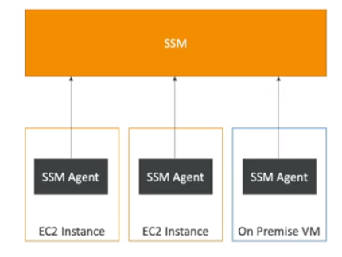

**SYSTEM MANAGER – SSM SESSION MANAGER**

* Allows you to start a secure shell on your EC2 and on-prem server, without any need of SSH access, bastion hosts, or SSH keys needed
* No port 22 needed (for better security)
* Supports Linux, Windows and macOS
* Sends session log data to S3 or CloudWatch logs

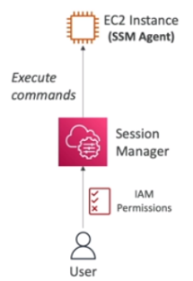

**Fleet manager** will show all the EC2 instances registered with SSM agent

**To remember** – SSM is kinda putty to access Windows or Linux EC2 instances.

**Systems Manager Parameter Store:**

* Secure storage for configurations and secrets like - API keys, password, configurations etc.
* It is serverless, scalable, durable, and easy to use
* Its secure as every parameter in the parameter store can be access controlled using IAM.
* Version tracking and encryption (optional) is also available